**B-APS**

Convergence Of E-commerce Grievance Support System

Project Purpose:

This presentation illustrates the functional specifications of the B-APS Grievance support services.

The following are the important modules of the project:

1. Registration and Logging in.
2. Selection of e-commerce website to redress client issue.
3. Selection of the type of issue, followed by issue related details.
4. Generation of reference number for the submitted issue.
5. Status enquiry using the reference number.
6. Acknowledgment with respect issue resolved.
7. Acknowledgment with respect to unresolved issue and time of completion
8. Feedback from Customer.

**1.1** Outlook of B-APS:

Steps and Actions:

1. User need to register the details for the B-APS access.

2. User will be able to enter details of the purchased product.

3. System should display all the necessary fields for the consumer.

4. Subsequent steps taken and issue resolved for customer with regard to complaint filed.

Business Rules & Validations

1. User cannot give false information and wrong claims.
2. All the mandatory fields should be entered.
3. Duplicate names other than registered name of the user are not allowed.

**1.2 Registration**

Customer should submit the prerequisite details for registration and login there by.

Pre-Conditions/Assumptions:

Customer database has to be maintained.

Post-Conditions:

Registered Customer details has to be maintained in database for future purpose.

Steps & Actions:

1. Login is must.
2. Customer can submit the details and access login.
3. User can submit the grievance.

Business Rules & Validations

1. Username and password has to be matched with customer database.
2. All the fields are mandatory.
3. Valid Email Address need to be provided.

**1.3 Submission of Grievance:**

*After completing successful login in B-APS application, the page gets navigated to the main page.

Pre-conditions/Assumptions:

In the main page all the necessary data are displayed. After clicking the respective e -commerce logo, user need to select the type of support required.

Post-conditions:

After submission of details, the main page navigates to Issue section.

Success End Condition:

Issue section gives user, freedom to choose from standard types of issues from consumer side.

Failure End Condition:

In case of any violation in the business rules of the fields, user needs to fill the details again.

Steps & Action:

1. Web page will display all the necessary fields in the screen.
2. System will store the user details into the database.

Business Rules and Logic

1. Details must be entered correctly.
2. Order and Non order issues need to be given accordingly.
3. No claims whatsoever will be entertained outside given jurisdiction as per the given norms.

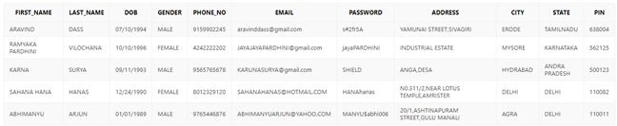

**1.4 Order Related Issue**

*User concern regarding the order placed

Pre-Conditions / Assumptions:

The required fields of product details columns to be filled correctly.

*Not delivered in defined time limit/date

*Damaged products

*Empty package

*Different Product

*Delivered but late

## *Returns.

Post Conditions:

Alert message will be generated in form of Reference Id.

Success End Condition:

Displays the alert message with respect to Issue filed.

Failed End Condition:

Displays the alert message for unsuccessful issue filed.

Steps & Action:

1. After submission of concern, Reference Id is shown along with the current status of the compliant and the maximum time frame for the issue to be resolved.

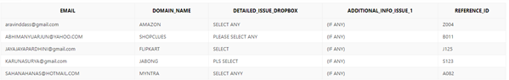

1.5 Non Order Related Issue:

User concern apart from the orders.

Pre-Conditions / Assumptions:

The required fields should be filled correctly.

*Login issue

*Product not found, incorrect product details and other product related issues

*Membership related issues

*Technical problems on ecommerce site

## *Offers

Post Conditions:

Alert message will be generated in form of reference Id for the issue raised.

Success End Condition:

Displays the alert message after submission of concern.

Failed End Condition:

Displays the alert message for unsuccessful issue filed.

Steps & Action:

1. After submission of concern, Reference Id is shown along with the current status of the compliant and the maximum time frame for the issue to be resolved.

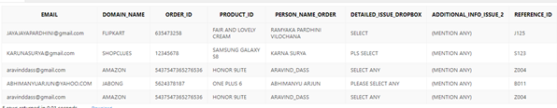

1.6 Feedback

User interface experience with B-APS services and application

* Responded politely and promptly.

* Excellent customer support tools.

* Ways to Improve

**Schema Diagram:**

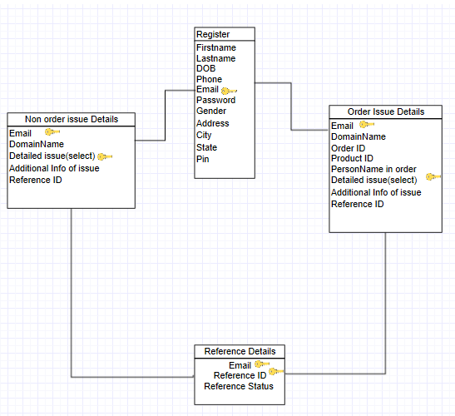

**Sequential Diagram:**

